25th National Family Practitioners Congress
18th-19th August 2023
The Wanderer’s Club

Sponsorship Opportunities
2023 Conference – South African Academy of Family Physicians (SAAFP)

TABLE OF CONTENTS

Letter of invitation……………………………………………………………… Page 3
Target audience………………………………………………………………… Page 5
Why sponsor and exhibit? ........................................................ Page 5
Sponsorship benefits grid.…………………………………………………….. Page 6
Other packages ………………………………………………………………… Page 7
Exhibition stands ……………………………………………………………….. Page 10
Exhibition floor plan ……………………………………………………………….. Page 11
Terms and conditions ………………………………………………………….. Page 12

Dear All
The South African Academy of Family Physicians represents family physicians in both the private and public sectors throughout South Africa. Our annual national conference will be held on 18th-19th August 2023 at the Wanderer’s Club in Johannesburg, with pre-congress workshops on the 17th of August 2023
The theme of the conference is “Integrating Primary Care - creating a more connected health and care system”.
Integrated care is an evidence-based and people-centred approach to enhance the quality, value and experience of care, improve population health and wellbeing, and increase job satisfaction in the workforce. We are all interconnected and interdependent. Therefore, we must engage with relevant stakeholders, adhere to good quality clinical practice and work towards comprehensive and holistic care.
With this in mind, we plan to focus on the following sub-themes during the conference:
- Population health and local context – disease surveillance, health promotion and preventative services
- Sharing patient care – team-based care
- Addressing multi-morbidity and long-term care
- Building professional capacity for integrated care
- Digital solutions
The conference will provide sessions on clinical topics, talks by invited speakers, presentations of original research, discussions on ethics and poster presentations.
Overall, we expect 300 participants, 8 invited speakers in the parallel sessions and 100 abstracts of original research. We offer a range of opportunities to engage with the participants and sponsor different aspects of the conference.

We invite you to participate as a sponsor and/or exhibitor at this congress. All sponsors and exhibitors will be offered exposure at the face-to-face congress as well as a dedicated exhibition space.
The congress attracts health professionals and family physicians in the public and private sectors as well as academic institutions.
We look forward to working with you at our congress.
Best wishes
Dr. Keshena Naidoo
Chairperson: SAAFP Congress 2023

WHO WILL BE ATTENDING THE CONGRESS?
• Family Physicians in Public & Private Health Sectors
• General Practitioners
• Government Health Departments
• Health Care Professionals
• Registrars (specialists in training)
• Medical Students
• Academics in the field of Family Medicine and Public Health

WHY PARTICIPATE AS A SPONSOR?
- Increase your pre-conference exposure through marketing coverage (website / social media and mailers)
- Raise your profile above your competitors
- Increase recognition and drive traffic to your exhibition stand and website
- Marketing exposure through branding and acknowledgement
- Contribute to and be actively involved in the development and growth of the industry and those that work in family medicine
- Deliver a greater ROI. Sponsoring an event can often be cheaper and have a higher return on investment than a TV commercial or other advertising methods
- Contribute to the upliftment of medical practice and research
- Increase your company’s perceived image
- Gain the respect and creditability of your target audience

WHY PARTICIPATE AS AN EXHIBITOR?
- Face-to-Face physical exhibition stand
- Pre-book one-on-one meetings sessions
- Launch new products
- Strengthen current product popularity
- Generate sales leads
- Reach new specific markets
- Meet with sector-specific audience
- Be recognised
- Brand trust: if you exhibit then you are more likely to be considered a serious business player
- Visibility: you might have a strong online presence, but to strengthen and grow, there also needs to be real visibility. People buy from people.
- Market intelligence – get to know your competitors and their products
- Keep up on industry trends and products that compliment your business

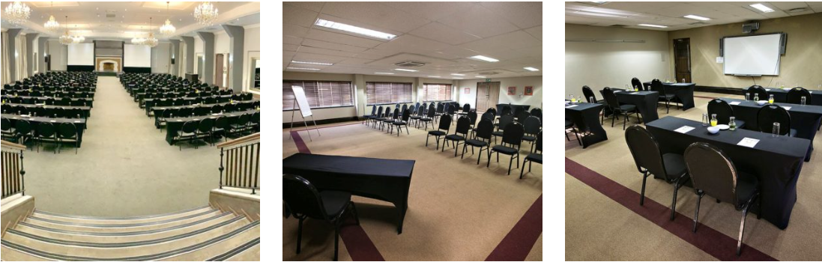
SPONSORSHIP BENEFITS GRID

DESCRIPTION | DIAMOND | PLATINUM | GOLD | SILVER | BRONZE
Value (incl. VAT) | R150,000 | R85.000 | R55,000 | R35,000 | R25,000
Number Available | 2 | 2 | 2 | 3 | 5
PRE-CONGRESS EXPOSURE
Logo to appear on marketing mailers prior to the conference | Yes – | Yes | Yes | Yes | Yes
Listing on the website (logo, company write-up, URL Link) | Yes  (200 words) | Yes  (150 words) | Yes  (100 words) | Yes  (80 words) | Yes  (50 words)
Banner advert on the conference website | Programme Page | Registration Page | Call for Abstracts Page
Social media exposure (content to be provided by sponsors) | 3 x mentions | 2 x mentions | 1 x mention
DURING CONGRESS EXPOSURE
Feature in Welcome video to be played at the conference while delegates wait for the session to start | Yes
Complimentary in-person conference attendee tickets | 2 | 1 | 1
Sponsor logo to appear on the conference website page (logo, word write up, URL link) | Yes | Yes | Yes | Yes | Yes
Sponsor video advert to play during breaks in pop-up host box (video to be supplied by sponsor. 1 x video) | Yes | Yes | Yes
Downloadable handout for attendees in Resource Gallery (sponsor to provide handout – 1 x PDF handout) | Yes | Yes | Yes | Yes | Yes
POST CONGRESS EXPOSURE
Listing on the website for 1 month after the conference (logo, word write-up, URL link) | Yes  (200 words) | Yes  (150 words) | Yes  (100 words) | Yes  (80 words) | Yes  (50 words)
Logo to appear on the post-conference mailer to all attendees | Yes | Yes | Yes | Yes

OTHER PACKAGES
OPPORTUNITY | COST | DETAIL
Invited Speakers | R25000.00 per speaker (plus honorarium if applicable)  - 8 Available  All will present in person at the congress venue  This fee covers:  - Registration  - Accommodation  - Transport  - Meals | Logo on congress website with URL link and 50-word company description (confirmed industry page)  Acknowledgement of contribution on congress programme & speakers’ page on the website  Listing in digital Congress Programme Book, 50-words (Sponsor and Exhibitor section) – available for download on the conference platform  Acknowledgement as a speaker sponsor on a slide to be displayed each Congress session (along with other speaker sponsor companies)  Logo on speaker’s page on the congress website  Logo in the digital Congress Programme Book on the programme page with acknowledgement as a speaker sponsor  Opportunity to use the speaker for a satellite symposium/workshop linked to the Congress.  Acknowledgement in the “Thank You to our Sponsors” digital ad which will be displayed on the virtual platform.  Analytics – list of everyone who viewed the session (where permission was granted)
Symposia | Pre-conference Workshop  - R35000  - 2 Available  Dinner Symposium  - R35000  - 1 Available  Breakfast (1 hour)  - R25000  - 2 Available per day  Lunch (45 minutes)  - R27,000  - 2 Available per day  Dinner Symposium  - R35,000 catering  - 1 Available  Gala Evening  - R115000  - 1 Available | Logo on congress website with a URL link and 50- word company description (confirmed industry page)  Listing & information on the satellite symposia page on the congress website (sponsor to provide details)  Logo, URL link and 50- word company description in digital Congress Programme Book (Sponsor and Exhibitor section) – available for download on the conference platform  One electronic email notification is to be distributed to all potential delegates and confirmed delegates prior to the congress  1x Dedicated alert distributed on the conference platform during the congress (content provided by sponsor)  Acknowledgement in the “Thank You to our Sponsors” digital ad which will be displayed on the virtual platform.

Educational Grants for Delegate Registrations | To be quoted on application.  Cost to cover delegate registration fees and/or travel/accommodation.  Applications are to be managed by SAAFP in conjunction with abstract submission. | Logo on congress website with URL link and 50- word company description (confirmed industry page)  Logo, URL link and 50-word company description in digital Congress Programme Book, (Sponsor and Exhibitor section) – available for download on the conference platform  Electronic brochure uploaded to the Resource Centre in the virtual exhibition.  Acknowledgement in “Thank You to our Sponsors” digital ad which will be displayed on the virtual platform
Congress Catering | R25000 per day | Acknowledgement of contribution on the congress website (sponsor page), conference platform, including company logo, URL link and 50-word company write-up  Opportunity to display branding at buffet stations and cocktail tables in the lunch and tea serving stations in the exhibition, including:  - Branded serviettes (supplied by sponsor)  - Branded overlays (supplied by sponsor)  - Branded coasters (supplied by sponsor)  - 4 x Pull-up banners (max size 2m x 0.8m) (supplied by sponsor)  - Tent cards (supplied by sponsor)  - Brochures / business cards

Poster Session  - All posters will be displayed | R 35,000  [Pre-conference] | Logo on congress website with a URL link and 50-word company description (confirmed industry page)  Logo, URL link and 50- word company description in digital Congress Programme Book (Sponsor and Exhibitor section) – available for download on the conference platform  Logo displayed on the poster session page of the congress virtual platform  Static advertisement on the poster session portal.  Acknowledgement in the “Thank You to our Sponsors” digital ad which will be displayed on the virtual platform  Analytics – list of everyone who viewed the poster session (where permission was granted)  Poster footage will be available for on-demand viewing for 3 months after the Congress.
Congress bags | R120 per bag x 275  - Congress bag to be selected by the organizing committee | The company logo is displayed on the bag alongside the SAAFP Congress branding  Acknowledgement of contribution on the congress website (sponsor page), conference platform, including company logo, URL link and 50-word company write-up
Congress notebooks (A5 hardcover journal style) | R85 per journal x 275  - Journal to be selected by the organizing committee | Logo on the front cover of the journal (1 colour print)  Acknowledgement of contribution on the congress website (sponsor page), conference platform, including company logo, URL link and 50-word company write-up
Congress pens | R25 per pen x 275  - Pen to be selected by the organizing committee | Logo on the pen (1 colour print)  Acknowledgement of contribution on the congress website (sponsor page), conference platform, including company logo, URL link and 50-word company write-up
Registration Sponsor  - Includes registration desk and staff, name badges and lanyards | R32,500 | Logo on registration desk, lanyard, and name badge alongside SAAFP Congress branding  Logo on registration page of the congress website  Acknowledgement of contribution on the congress website (sponsor page), conference platform, including company logo, URL link and 50-word company write-up

EXHIBITION STANDS

- Exhibition stand at The Wanderers _ JHB open for the full duration of the conference
- “Live time” to interact with attendees
- Upload 2-3 min video footage on your stand to highlight your company or product/services
- Logo featured in a “Visit our Exhibition” digital advert which will be displayed
- Logo and URL link on the congress website (under the exhibitor’s page)
- Participation in the “Treasure Hunt” to drive people to your exhibition stand

DESCRIPTION | PRICE (VAT incl.)
3m x 3m Exhibition stand (8 stands available) | R35,000
3m x 5m Exhibition stand (4 stands available) | R55,500

EXHIBITION FLOORPLAN
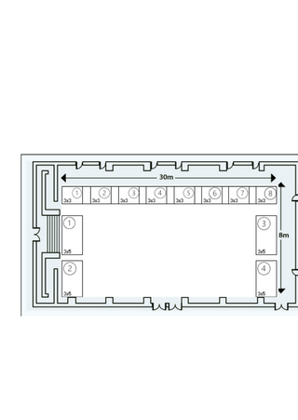
SAAFP Lounge

TERMS OF PAYMENT
- 50% Deposit required on signing of contract
- Balance payable 30 June 2023

TERMS AND CONDITIONS
- An invoice and sponsorship contract will be sent to you within 72 hours of receipt of the Commitment Form.
- Selection of sponsorship is on a first-come-first-served basis.
- The Commitment Form does not constitute a legal and / or contractual engagement. It only serves as an indication of intent to proceed with the chosen commitment.
- Sponsorship, however, is only confirmed on receipt of a signed contract and payment of a 50% deposit or receipt of a purchase order. ROI will be affected once this has been received.
- Failure to comply with the payment schedule could result in the forfeiture of your commitment, and any refund due will be at the discretion of the Congress Organising Committee.
- All sponsorship contracts are final and cannot be retracted.
- The Congress Organising Committee reserves the right to decline sponsorship bookings.
- The law of South Africa governs this contract.
- The Congress Organising Committee reserves the right to amend the rules and regulations governing sponsorship at its discretion.
- Logos must be provided in jpeg format and emailed to charne@soafrica.com within 24 hours of payment of a deposit and signed a contract to ensure that we are able to offer maximum exposure.
- Cancellation policy:
  - All cancellations must be received by the Congress Secretariat in writing – to admin@saafp.org
  - Cancellations received prior to 30 April 2023 will forfeit a 10% cancellation fee
  - Cancellations received between 1 May 2023 and 30 June 2023 will forfeit the 50% deposit paid.
  - Cancellations received from 1 July 2023 will be liable for the full value committed.
CONTACT US:

Lucille Boshoff Keshena Naidoo
SAAFP Administrator Senior Lecturer
eMail: admin@saafp.org eMail: naidook7@ukzn.ac.za
Tel: 0833016771/0604088569 Tel: 0836536077

